
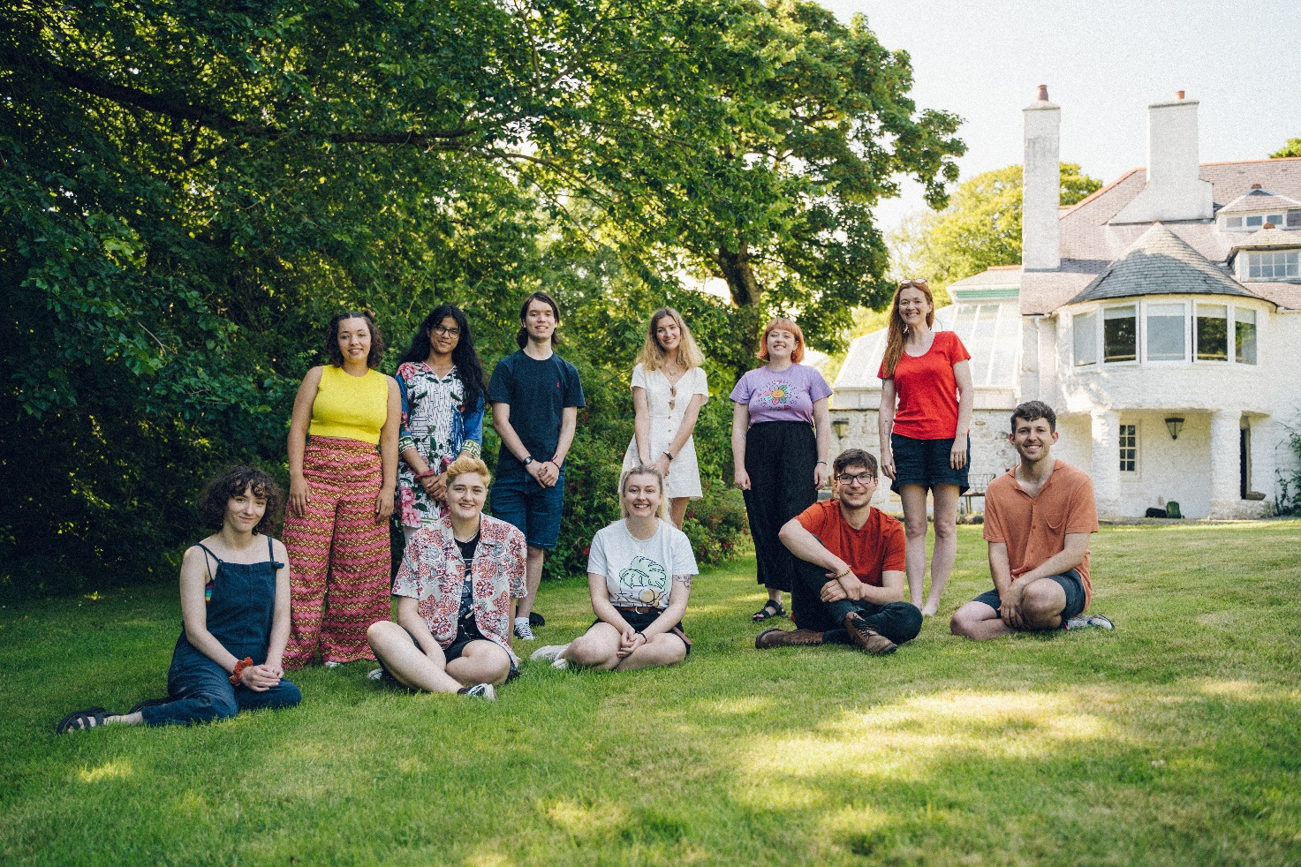
Authors and Co-Authors of YA series Y Pump on a retreat at Literature Wales’ Tŷ Newydd Writing Centre © Kirstina Banholzer
Operations Support
x
Full-time (37 hours per week) 12-month contract
To start as soon as possible
Salary: £20,000 per annum
Location: Tŷ Newydd Writing Centre, Llanystumdwy, Gwynedd.
The position will also have occasional flexibility to work remotely.
Closing Date: midday, Friday 29 April 2022 Interviews: 10-11 May 2022

Our recruitment policy
Literature Wales is an inclusive organisation committed to welcoming candidates from a wide range of backgrounds. We assess applications on the strength of potential, and we will take positive action by guaranteeing an interview to every applicant who meets the suitability requirements of the role and who identify as under-represented within the literary sector. Our aim is to develop literature as an art form that is representative and accessible for everyone in Wales. We believe that we can best deliver that aim by creating a diverse workforce with varied lived experiences.
For more information, please see our Equality, Inclusion, Diversity Plan. If you would like to apply for this role but are uncertain whether you have sufficient experience, please contact us for an informal chat.
Our recruitment framework has been developed as part of the Weston Jerwood Creative Bursaries Programme, which supports arts organisations to expand their approach to diverse recruitment and talent development.

Literature Wales - About us
Literature Wales is the national company for the development of literature. Our vision is a Wales where literature empowers, improves and brightens lives. Our aim is to inspire communities, develop writers, and celebrate Wales’ literary culture. We work in partnership with a range of organisations across Wales and beyond to collectively achieve our ambitions for a more equal sector. Based on our understanding of the power of literature to improve and transform lives, our priorities are themes which feature in everything we deliver, they are, Representation and Equality, Health and Well-being, and the Climate Emergency.
We are a member of the Arts Council of Wales’ Arts Portfolio and are one of eight National Art Companies.
We are a friendly, creative and collaborative team that works in Welsh, English and bilingually across Wales. Our offices are based in Llanystumdwy and Cardiff, occasionally we work from home and we will provide you with necessary equipment, including a leased laptop.

About the Role
This is a dynamic and exciting role which supports the day-to-day running of Tŷ Newydd Writing Centre and its writer development courses. The Operational Support will play an important role in representing Literature Wales and our values when welcoming and assisting guests and visitors. This will include dealing with enquiries about accommodation and course logistics, hosting and occasionally chairing literary events, and facilitating virtual elements of our activity. The ability to speak Welsh is essential for this role.
The Operational Support will contribute ideas to, and implement, Tŷ Newydd’s sustainability action plan, in line with Literature Wales’ commitment to addressing the Climate Emergency through our work. The role will also work closely with the community in Llanystumdwy to develop literature for health and well-being opportunities.
The role will also assist with operational and administrative tasks at the office, and for some of Literature Wales’ key projects, including the Wales Book of the Year Awards.

The Operational Support will:
- Greet and welcome guests to Tŷ Newydd such as course tutors, writers and visitors. This will include practical health and safety briefings and leading welcome sessions.
- Develop and implement exciting virtual elements to residential courses, to increase the accessibility of Tŷ Newydd’s activities for disabled writers and writers with caring responsibilities.
- Supervise educational group visits, including chaperoning on nature walks, and providing occasional fun activities in between the workshops.
- Help with practical duties at Tŷ Newydd including light cleaning and preparing of site, and deputising for the Catering and Hospitality Co-ordinator in preparing meals. (We will provide the appropriate training to gain any essential accreditation required e.g. Food Hygiene Certificate Level 2).
- Work closely with the Venue Manager and Creative Lead to develop new activity at Nant Writers’ Retreat aimed to strategically address our Representation & Equality priorities.
- Administrate bookings at Nant Writers’ Retreat and working closely with the wider team to increase marketing exposure for the cottage and its activity.
- Develop community engagement work, including working with the Creative Executive on literature for health and well-being projects with local groups.
- Engage in office management duties, including answering the phone and responding to email queries.
- Administrative tasks including collating, maintaining and inputting data via Microsoft Excel, project planning, and logging SurveyMonkey applications and feedback.
- Support the Communications Executive with marketing Tŷ Newydd courses and increasing sales.
- Support with the delivery of the Wales Book of the Year Awards.
- Any other tasks as required by the organisation.
Reporting to:
- Tŷ Newydd Venue Manager

A day in the life of the Operational Support
During your working day you’ll be multitasking, ensuring the smooth running of Tŷ Newydd as a residential centre, whilst paying close attention to administrative responsibilities, including answering time-sensitive queries.
You will play an important part welcoming guests to residential courses by preparing the site, leading informative and fun tours of the house and gardens, responding to queries from writers and tutors and ensuring they feel at home at Tŷ Newydd. Some evenings you will meet, share a meal and brief the course participants on their stay, or you might chair an exciting programme of guest reader events – featuring some of the best writers in Wales and beyond.
During educational courses, you will spend time with children and young people to ensure that their visit is safe, enjoyable and in keeping with Literature Wales’ values, priorities and safeguarding procedures.
You will work closely with the small team of colleagues based at Tŷ Newydd on new, innovative and creative ideas to engage the community in our work, develop the business, and to ensure that strategic aims are met. This could include developing a new virtual set-up to maximise the experiences of writers joining residential courses virtually, or devising a themed call-out for writers from low-income backgrounds to apply for free retreats at Nant – our Writers’ Retreat.
You will often join virtual meetings with colleagues based around Wales to offer operational support and feed creative ideas towards some of Literature Wales’ flagship projects. This role is customer facing, fast-paced and varied, but highly rewarding and sociable as you will meet a wide range of interesting visitors each week.
Suitability for the role
We’re looking for someone who has:
- The ability to multitask, to work well under pressure, and to prioritise responsibilities.

- Experience in the hospitality sector, and/or demonstratable practical skills including cleaning, catering, Zoom-hosting, and light site-upkeep.

- The ability to complete detailed administrative responsibilities using Microsoft Office systems and web-based systems, e.g. SurveyMonkey and Mailchimp.
- Confident and positive written and verbal communication skills in both Welsh and English, and the confidence to greet and host community groups, and groups of children and young people.
- An interest in literature, and the power of the arts to address social justice issues.
- An outgoing, positive and confident approach to work.

Please note, this role requires a commitment to working flexible hours including some evenings, weekends and bank holidays, which are exchanged for time in lieu, to provide a high-quality hospitality service to Tŷ Newydd residential guests and visitors. A timetable of these flexible hours will be drawn up in advance to allow staff members to make arrangements.

We especially encourage applications from individuals who identify with one or more of the following statements:

- I come from a Black, Asian or Minority ethnic background.
- I am disabled or I live with a long-term illness (mental or physical).
- I come from a low-income background.

Applicants who identify with one or more of these statements, and who meet the suitability requirements of the role, will be guaranteed an interview for this position. We are passionate about addressing inequalities and under-representation in the arts and will prioritise lived experience above work experience.
Literature Wales recognises its duty to safeguard children and adults at risk as they attend or participate in the literary arts. As such, all roles at Literature Wales are subject to passing a DBS check, with a disclosure level appropriate to the role. Literature Wales reserves the right to terminate employment or rescind offers of employment if the DBS check result could threaten the safety of children and adults at risk. In line with the Rehabilitation of Offenders Act (1974) and our policy for inclusive recruitment, if you would like to discuss this with us confidentially before you apply, please let us know.

How to apply

- Please read the above job description and suitability list carefully. Also, please read Literature Wales’ Strategic Plan for 2019-2022 here and our 2019-2022 Mid-Term Report here.

- Please write an application letter or create a video application* to explain why you are interested in the role and how you are suitable for it (e.g. tell us about your experience and what interests you about specific elements of the role). Both formats are acceptable and of equal value.

*Max. 2 pages of A4 or 5-minute video.

- Send the following to post@literaturewales.org by midday Friday 29 April 2022
- Your application letter or video.
- Your CV** and the details of two referees who know you in a professional context. We will only contact referees after an offer of employment has been accepted.
- A completed Literature Wales Equality and Diversity Form (available here).
** Max 2 pages of A4.

What will happen next?
We will assess the applications and invite successful candidates to an interview on 10 or 11 May 2022. There will be three people on the interview panel representing the Literature Wales team.
Although this will be a formal interview, we will ensure that each candidate is comfortable with the interview process. If the interview process causes you any concern, please let us know in advance and we can arrange an informal meeting or chat over telephone or video call with Leusa Llewelyn, Creative Lead – Tŷ Newydd, before the interview.
Please feel free to contact us to discuss the role informally, or to ask for further information. To speak with Leusa Llewelyn directly, or to arrange a call back, please e-mail her at leusa@literaturewales.org.
We will contact all the candidates with the outcome of the interviews by Wednesday 18 May 2022.

Literature Wales is a registered charity that works with the support of the Arts Council of Wales and the Welsh Government.

