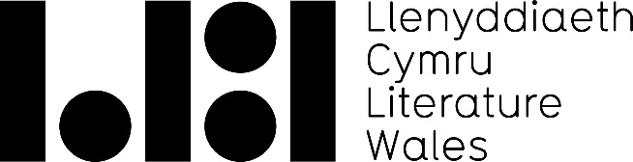

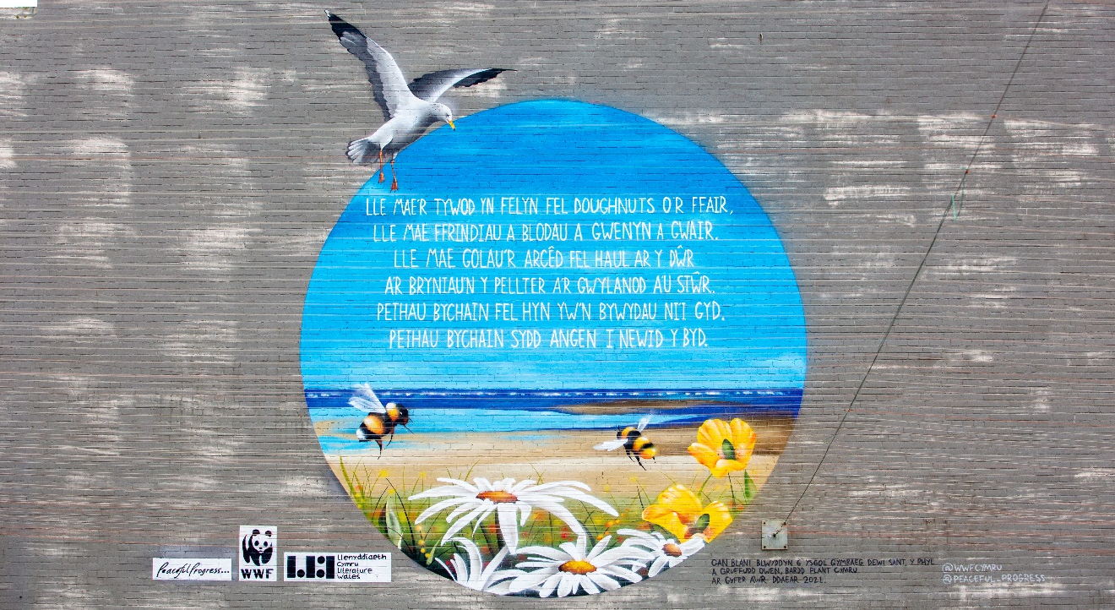
Communications Executive
x
Full-time, fixed term contract (37 hours per week for 12 months)
To start as soon as possible
Salary: £25,000 pro rata
Location: Our offices are in Llanystumdwy and Cardiff.
The position is currently working remotely and all requests for location flexibility will be considered.
Closing Date: 29 April 2022 Interviews: 10-11 May 2022

About us
Literature Wales is the national company for the development of literature. Our vision is a Wales where literature empowers, improves and brightens lives. Our aim is to inspire communities, develop writers, and celebrate Wales’ literary culture. We work in partnership with a range of organisations across Wales and beyond to collectively achieve our ambitions for a more equal sector. Based on our understanding of the power of literature to improve and transform lives, our priorities are themes which feature in everything we deliver, they are, Representation and Equality, Health and Well-being, and the Climate Emergency.
We are a member of the Arts Council of Wales’ Arts Portfolio and are one of eight National Art Companies.

We are a friendly, creative, and collaborative team that works in Welsh, English and bilingually across Wales. Our offices are based in Llanystumdwy and Cardiff. We occasionally we work from home, and we will provide you with necessary equipment, including a leased laptop.

About the Role
This is an exciting and creative role where you will support the development of Literature Wales’ brand and help us to tell our story. You will assist with the implementation of our Communications Strategy, which includes working across many disciplines, including marketing, digital promotion, and PR.
You will be responsible for ensuring that Literature Wales’ messaging is consistent and engaging. The main responsibilities include promoting our opportunities and services, distributing our key communications messages, and sharing the impact of our work. This will mean creating and disseminating exciting content for our digital channels, forward planning communications activities, audience development, copywriting and editing, and analysing the success of our communications activity.
Working in a small and dynamic team, you will contribute to better visibility of Literature Wales’ remit and impact, increased sales of Tŷ Newydd creative writing courses, and a growth in our client base.

The Communications Executive will:
- Assist the Interim Communications Lead on the implementation of the organisation’s Communications Strategy, specifically the forward planning of digital content.
- Assist colleagues to promote their services, opportunities and projects by helping them to create and implement marketing or promotional plans.
- Implement our social media strategy, which includes writing posts, managing content, and analysing campaigns for our main platforms, Twitter, Facebook and Instagram.
- Lead on the marketing for Tŷ Newydd creative writing courses, developing its audience base, generating sales and maintaining its marketing directory.
- Manage our websites, creating and updating content to ensure each site is current, correct and a valuable resource for our audiences.
- Write and design newsletters for external and internal audiences.
- Create digital content which include videos, flyers, adverts, and social media assets.
- Communicate organisational impact by creating case studies, writing blog posts and designing infographics.
- Manage and evaluate our organisational media library, which includes maintaining a log of press & media coverage and digital engagement statistics, and reporting your analysis to the Communications Team
- Answering enquiries about the Writers of Wales Directory, and supporting its development.
- Support the running of our Inspiring Communities Fund, which provides funding for events.
- Write, proof-read and translate copy.
- Support with the promotion of key projects, including the Wales Book of the Year Awards.
- Any other tasks as required by the organisation.

Reporting to:
- Communications Lead

A day in the life of the Communications Executive
During your working day you’ll be multitasking on a range of activities, using your creativity to play an important part in telling Literature Wales’ story. This is a fast-paced and varied role, striking a balance between precise planning of messaging and reacting quickly to unforeseen requests and opportunities.
As a member of the Communications Team, you will work closely with colleagues across the organisation whether based at our offices in Tŷ Newydd, Llanystumdwy or the Glyn Jones Centre, Cardiff. You will collaborate to develop plans for marketing and promotion. You will also discuss ways to celebrate the impact of our work on individuals and communities.
You will have a particular focus on writing and creating content for our social media platforms and websites. You will use design tools such as Canva and Photoshop, and will become acquainted with WordPress, Mailchimp and scheduling programmes such as Tweetdeck and Facebook Business.
You will work closely with colleagues programming and running creative writing courses at Tŷ Newydd. You will work on ways to increase sales and extend the reach of the services and opportunities we offer at the centre. This could include placing magazine adverts, requesting testimonials, and offering reciprocal social media marketing to several organisations.
At certain points in the year, you will offer your colleagues concentrated communications support and feed creative ideas towards some of Literature Wales’ flagship projects, including the Wales Book of the Year Award, the National Poet of Wales initiative, and the Representing Wales professional development programme.
Some days, you will concentrate on administrative and operational tasks such as gathering and analysing data from Google and social media analytics, updating content on our website, proofreading and translation. You will often interact with stakeholders outside the organisation, answering enquiries which are raised by email or over social media.
You will regularly join meetings – some virtually and some in person - where you will contribute to our wider strategic development and project planning with colleagues across the organisation.

Suitability for the role
We’re looking for somebody who has:
- The ability to multitask, to work well under pressure, and to prioritise responsibilities.
- Experience and knowledge of the communications and marketing disciplines.
- Experience of managing organisational social media accounts, especially Twitter, Facebook, and Instagram.
- Experience of copywriting and proofreading.
- Strong, sensitive and positive communication skills in both Welsh and English. This applies to both written and verbal communications.
- Highly organised, and can manage time and prioritise tasks.
- An interest in literature, and the power of the arts to address social justice issues.
The following are desirable attributes:
- Experience of graphic design.
- Experience of video creation and editing for social media.
- Experience of audience development, including but not restricted to developing marketing lists.
- Experience of project management.

We especially encourage applications from individuals who identify with one or more of the following statements to apply:
- I come from a Black, Asian or Minority ethnic background.
- I am disabled or suffer from long-term illness (mental or physical).
- I come from a low-income background.
Applicants who identify with one or more of these statements, and who meet the suitability requirements of the role, will be guaranteed an interview for this position. We are passionate about addressing inequalities and under-representation in the arts and will prioritise lived experience above work experience.
Literature Wales recognises its duty to safeguard children and adults at risk as they attend or participate in the literary arts. As such, all roles at Literature Wales are subject to passing a DBS check, with a disclosure level appropriate to the role. Literature Wales reserves the right to terminate employment or rescind offers of employment if the DBS check result could threaten the safety of children and adults at risk. In line with the Rehabilitation of Offenders Act (1974) and our policy for inclusive recruitment, if you would like to discuss this with us confidentially before you apply, please let us know.

Our recruitment policy
Literature Wales is an inclusive organisation committed to welcoming candidates from a wide range of backgrounds. We assess applications on the strength of potential, and we will take positive action by guaranteeing an interview to every applicant who meets the suitability requirements of the role and who identify as under-represented within the literary sector. Our aim is to develop literature as an art form that is representative and accessible for everyone in Wales. We believe that we can best deliver that aim by creating a diverse workforce with varied lived experiences.
For more information, please see our Equality, Inclusion, Diversity Plan for 2020-23. If you would like to apply for this role but are uncertain whether you have sufficient experience, please contact us for an informal chat.
Our recruitment framework has been developed as part of the Weston Jerwood Creative Bursaries Programme, which supports arts organisations to expand their approach to diverse recruitment and talent development.

How to apply

- Please read the above job description and suitability list carefully. Also, please read the Literature Wales Strategic Plan for 2019-2022 here and our 2019-2022 Mid-Term Report here.

- Please write an application letter or create a video application* to explain why you are interested in the role and what how you are suitable for it (e.g. tell us about your experience and what interests you about specific elements of the role). Both formats are acceptable and of equal value.
*Max. 2 pages of A4 or 5-minute video.

- Send the following to post@literaturewales.org by 29 April 2022:

- Your application letter or video
- Your CV** and the details of two referees who know you in a professional context. We will only contact referees after an offer of employment has been accepted.
- A completed Literature Wales Equality and Diversity Form (available here).

** Max 2 pages of A4.

What will happen next?
We will assess the applications and invite successful candidates to a digital interview on the 10th or 11th of May. There will be three people on the interview panel representing the Literature Wales team.
Although this will be a formal interview, we will ensure that each candidate is comfortable with the interview process. If the interview process causes you any concern, please let us know in advance and we can arrange an informal meeting or chat over telephone or video call with Branwen Llewellyn, Interim Communications Lead, before the interview.
Please feel free to contact us to discuss the role informally, or to ask for more information. To speak with Branwen Llewellyn directly or to arrange a call back, please e-mail her at branwen@literaturewales.org.
We will contact all the candidates with the outcome of the interviews by 18 May 2022.

Literature Wales is a registered charity that works with the support of the Arts Council of Wales and the Welsh Government.

